Group #1

Glorioso, Jose Miguel

Pino, Alexander

Rosario, Dane Lauren

Tan, Jeremy Marcus

Selected Use Case: LoL Esports Analytics

As avid League of Legend players, we decided to make a database that could help casual and seasoned League players in their own games as well as enhance their viewing experience while watching professional matches. We analyzed a database of statistics from LoL competitive matches from Kaggle. Using MongoDB, a managed NOSQL database, we created a database of match and champion (playable characters) statistics. We gained various insights and realizations from our data such as the most played and banned champions, the champions with the highest win rate, the professional players with the most kills and assists, and the strongest teams in a particular year. Our data analysis can be further expanded on by taking into account other statistics not covered in the video like gold generation and the matchup statistics of a champion.

Much like in traditional sports, in esports, statistics and infographics are used in broadcasts to help viewers understand the game dynamics in a particular game, such as the players who have had a historically high win rate over another player. With the use of a comprehensive database of competitive LoL matches, we streamlined an easy and efficient way of producing statistics about competitive league of legends.

Selected Database: MongoDB

Our group decided to use the MongoDB framework instead of the DynamoDB framework because of the limitation of having only two variables for the primary key. There are a lot of different variables in a League of Legends (LoL) Esports game which include champions, kills, deaths, assists, match info, etc. MongoDB enables us to more easily query the database and find the needed values. We utilized sharding in order to divide the workload into three shards of data and make data access more efficient. In total, we used three csv files taken from Kaggle which we modified for our use case.

Examples of use case:

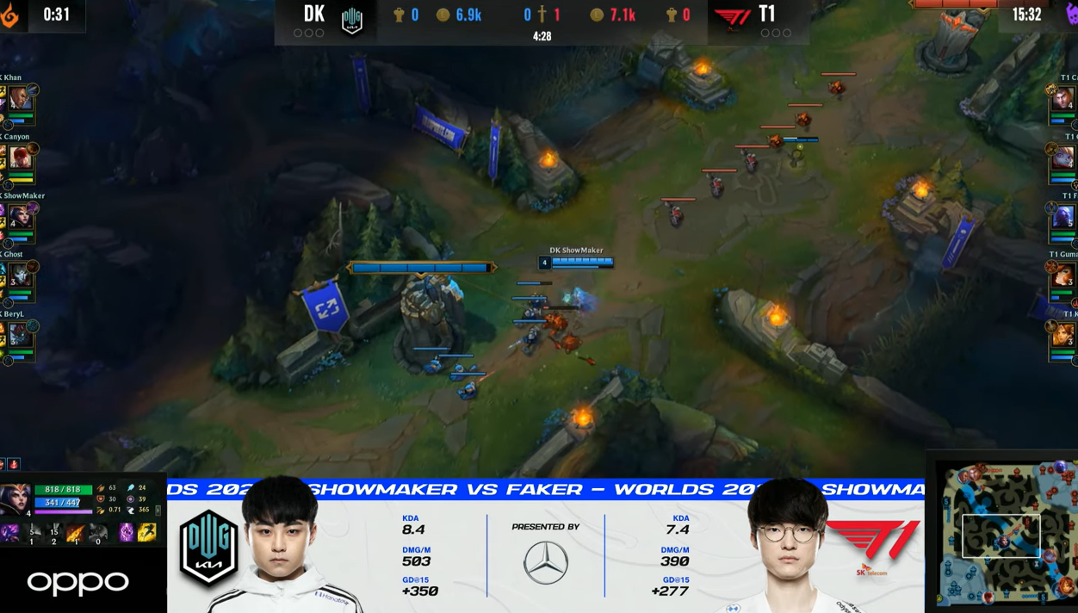

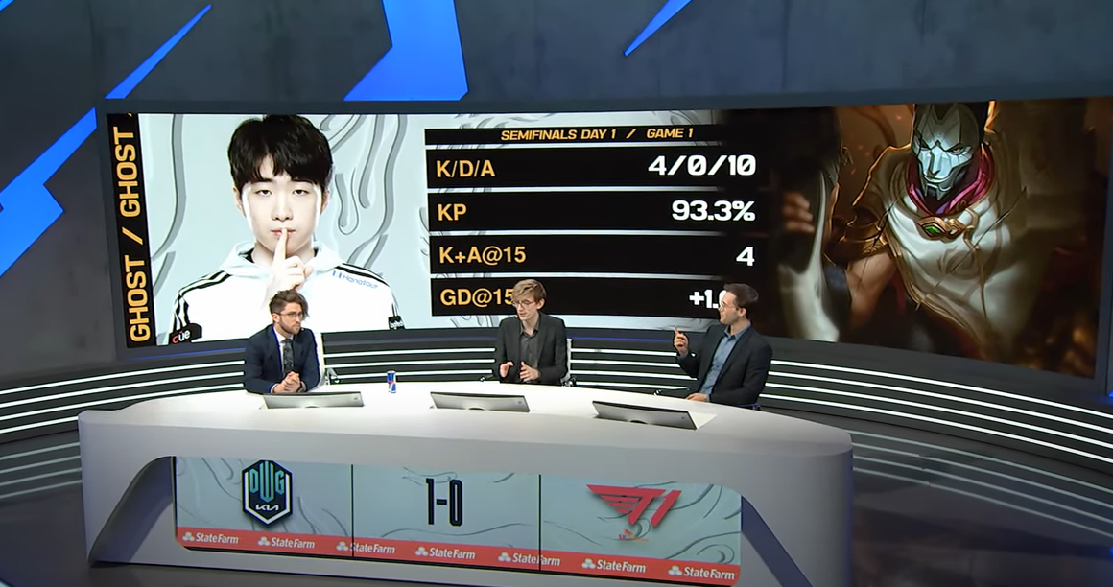

Source: https://www.youtube.com/watch?v=BqTv7F61yUM

Dataset: https://www.kaggle.com/chuckephron/leagueoflegends